***Science* Manuscript Template Instructions**

**General Instructions on using this template and submitting a manuscript to *Science*:** Thank you for preparing a manuscript for submission to *Science*. Using this template, or following the guidelines below, will help us in processing your paper. Our goal is to be able to identify each section of your manuscript so that we can accurately record the title, authors, abstract, etc. and to enrich it by including reference links and an accurate layout.

Please use the actual template, which starts on page 2. When you are ready to submit, please delete the text on this cover page.

You can submit your paper at <https://cts.sciencemag.org>.

Additional information for authors is available at [http://www.sciencemag.org/authors/science-information-authors](http://www.sciencemag.org/site/feature/contribinfo/index.xhtml).

If you are using LaTeX, please convert your paper into a Word .docx file if possible. If this is not possible, please use our LaTeX template and upload a PDF version of your paper. Some conversion approaches are available here: <http://www.tug.org/utilities/texconv/textopc.html>.

So that we can identify the parts of your paper, and even if you do not use our template, please begin each section with the specific key words listed below, some of which are followed by a colon. Please do not use paragraph breaks in the title, author list, or abstract. The author list, corresponding author email(s), and affiliation(s) should be checked carefully because they will be published as listed in the manuscript.

**Title:** No more than 96 characters, lacking jargon and abbreviations where possible.

**Authors:**

**Affiliations:**

**One Sentence Summary:** No more than 40 characters.

**Abstract:** 125 words or less.

**Main Text:**

**References and Notes:** (Followed by a numbered list); only a single reference list should be provided for the main text and supplemental information.

**Acknowledgments:** Split into sections as described below.

**List of Supplementary Materials:** Include a list, noting which references are only cited in the SM.

**Fig. #.** (Begin each figure caption with a label, “**Fig. 1.**”, for example, as a new paragraph.)

**Table #.** (Begin each table caption with a label “**Table 1.**”, for example, as a new paragraph.)

**Supplementary Materials:** Comprising Materials and Methods, figures, and tables; should be in a separate file.

Please use the .docx format (all versions after Word 2007). If you chose not to use this template, please include page numbers in your submitted file. We also encourage use of line numbers.

More specific formatting instructions are provided in the template which follows.

Title: Transmission Tracing for SARS-CoV-2 Outbreak Mitigation Using Rapid, High-Specificity Testing

**Authors:** Lee Kennedy-Shaffer1,2*, Michael Baym3, William P. Hanage1,2.

**Affiliations:**

1Center for Communicable Disease Dynamics, Harvard T.H. Chan School of Public Health, Boston, MA, USA.

2Department of Epidemiology, Harvard T.H. Chan School of Public Health, Boston, MA, USA.

3Department of Biomedical Informatics, Harvard Medical School, Boston, MA, USA.

*Correspondence to: Lee_Kennedyshaffer@g.harvard.edu.

**Abstract:** Preventing future infection waves of COVID-19 will depend on effective and efficient contact tracing that can identify and prevent superspreading events. SARS-CoV-2 transmission appears to be characterized by high individual variation and a large role of superspreading events. Taking this into account can improve the cost-benefit tradeoffs of contact tracing. In particular, an individual who is known to have transmitted the infection once is more likely to have transmitted to other individuals. We propose a strategy of identifying transmission events rather than simply identifying infected individuals, making use of the high variability in secondary case numbers. With a rapid, high-specificity, low-sensitivity test, this strategy can lead to the isolation of a large proportion of infected individuals while drastically reducing the isolation of uninfected contacts.

**One Sentence Summary:** Tracing transmission events rather than infected individuals can efficiently and effectively prevent infection waves.

**Main Text:**

Recently, attention has focused on superspreading events (SSEs) as a key component in the transmission dynamics of SARS-CoV-2. Several articles have identified a large role for SSEs in understanding observed disease clusters (*1, 2*) and in reproducing observed transmission patterns (*3, 4*). Further, the low rate of within-household transmission, although higher than similar pandemic respiratory diseases, implies that the person-to-person variance in transmissibility is particularly high (*5*). This has led to suggestions that prevention and mitigation of SSEs, along with contact tracing that targets such events, can be particularly impactful in reducing transmission (*6–8*). This is even more true if, as has recently been suggested, biological mechanisms drive SSEs and lead to individuals infected in an SSE being more likely to cause a future SSE than individuals infected through smaller transmission events (*9*).

As the COVID-19 pandemic continues, growing and declining in various countries around the world, “test and trace” strategies are becoming an increasingly important part of strategies to address the virus (*10–14*). These strategies can be highly effective in halting transmission chains (*14, 15*), but rely heavily on rapid availability of test results and/or presumptive isolation of many asymptomatic contacts (*10–12, 16*). The success of these strategies also relies on the efficiency with which cases and contacts are identified (*17*). In order for testing strategies and contact tracing strategies to be most effective, they must account for SSEs and the latest evidence of their importance in the transmission of SARS-CoV-2.

A key implication of the high frequency of SSEs and, more generally, the overdispersion of infectivity is that once you know a person has transmitted SARS-CoV-2, the probability that they have transmitted to multiple people increases dramatically. Given that all current testing technologies have fairly high false-negative rates (*18–20*), the information that an index individual has infected a contact is a strong and useful predictor of infection and future disease among other contacts. A rapid, highly-specific but not very sensitive test for SARS-CoV-2 could improve the risk-benefit analysis and more appropriately balance the short-term costs of isolation with the long-term benefits of reducing the spread of the disease (*12*). In this article, we consider a strategy for balancing these costs and halting transmission chains through use of such a test.

Traditionally, contact tracing focuses on identifying infected individuals and presumptively isolating all of their contacts (*10*). In a setting where SSEs are a major source of infections, identifying transmission events provides substantially more information about prospective cases than identifying infected individuals alone. Therefore, we propose the following strategy for transmission tracing of an identified index case:

1. Test all potential contacts of the index case using a rapid, high-specificity test.
2. If **any** contacts test positive, isolate **all** contacts and conduct more thorough epidemiological assessments of these individuals. This may include more accurate testing, active monitoring, presumptive quarantine or self-isolation (with appropriate support measures to ensure it can be followed), and tracing of their contacts, potentially using this same strategy. Peak et al. discuss the tradeoffs of different approaches to monitoring and quarantine (*17*).
3. If **no** contacts test positive, all contacts are presumptively treated as negative and self-isolation is not suggested.

Or, equivalently, if an individual tests positive, and the source of infection can be identified, immediately isolate **all** contacts of the **source** and conduct more thorough testing.

Both formulations rely on the key point that identification of a transmission event is far more informative of the infection state of other individuals than a positive test result alone.

A schematic of this strategy is given in **Figure 1**, denoted (A). This strategy can be compared to two alternative approaches to contact tracing: (B) isolating all contacts and, potentially, their contacts until a high-accuracy test can be performed or the period of potential asymptomatic transmissibility has passed; or (C) providing a rapid, moderate-accuracy test to to all contacts and isolating only those who test positive.

This approach relies on the availability of a rapid, high-specificity test. The sensitivity of the test, however, need not be high. Under this strategy, if an index individual infects four other individuals, a test with sensitivity of 50% will identify that group over 90% of the time.

Models for SSEs generally consider the overdispersion of the number of secondary infections caused by an index infection as an individual-level random variable rather than a single R0 (*21*). This model, appropriately parameterized for a given disease, can provide an estimate of the distribution of secondary infections and thus the pattern of transmissions in a community. Estimated ranges for these parameters for SARS-CoV-2 have recently been proposed (*1, 22*).

To assess the effectiveness of this approach in reducing transmission, we can determine the expected number of secondary cases that are identified and isolated through this strategy compared to a strategy that isolates all contacts. This number depends on both the sensitivity of the test, denoted *a x 100%*, and the distribution of the number of secondary cases infected by an index individual, denoted *Z*. We assume that *Z* follows a negative binomial distribution with mean R0 and dispersion parameter *k* (*21*). Note that a higher value of *k* indicates more SSEs. For simplicity, we assume perfect specificity of the test.

**Figure 2** displays the proportion of secondary cases isolated using transmission tracing (strategy A) for a range of values of *a*. Several values of R0 and *k* are considered, within estimated ranges for SARS-CoV-2; R0 is taken to be between 1.5 and 3 and *k* between 0.1 and 1 (*1, 22*). The diagonal line indicates the proportion of secondary cases isolated if only the individuals who test positive are isolated (strategy C).

When there is overdispersion of transmission, the proportion of cases who are isolated is drastically higher using the transmission tracing strategy than only isolating contacts who test positive. Even for a test with sensitivity of 50%, for all parameter values considered here, over 80% of cases are isolated. There are also decreasing returns to increased sensitivity of the test, especially for lower values of *k*. If there are lower-sensitivity tests available that can be deployed more quickly and more cheaply, the logistical advantages of those tests may make up for the decreased accuracy in the context of this approach.

To assess the cost of this approach in terms of isolation and follow-up, we can determine the proportion of index cases whose contacts are isolated compared to a strategy that isolates all contacts. Again, this will depend on the sensitivity of the test and the distribution of the number of secondary cases infected by an index individual. **Figure 3** displays the proportion of index cases whose contacts are isolated using this strategy for the scenarios shown in Figure 2. This proportion is much lower than 100% for all parameters considered here, representing a significant decrease in the number of index cases whose contacts are isolated compared to strategy B.

Note that this proportion is not necessarily equal to the proportion of identified contacts who are isolated. If the number of secondary cases infected by an index individual increases as the number of identified contacts increases, those index individuals whose contacts are isolated will, on average, have more contacts than those whose contacts are not isolated. In any case, only isolating cases who test positive will result in a lower number of individuals isolated, but this difference is more pronounced if the number of secondary cases is highly correlated with the number of identified contacts.

We have proposed a testing and tracing approach that uses rapid, high-specificity, low-sensitivity tests and takes advantage of the transmission dynamics of SARS-CoV-2. By focusing on identifying transmission events and then isolating all other contacts of that index individual, SSEs have a high chance of being identified while the likelihood of isolating uninfected contacts is reduced.

Transmission tracing provides a means to drastically reduce the burden of quarantine/isolation and successive contact tracing while still identifying the vast majority of transmission events and, especially, superspreading events. This can occur even using tests with sensitivity of 50% or less. It can be modified to focus on specific types of contacts or events. For example, this approach can be used to rapidly test all contacts in specific workplaces, campuses, residential facilities, or other locations where SSEs are likely to occur (*7, 23*). This provides another approach, like group testing, to identify SSEs in these locations without the expense and delay of individual contact tracing (*24, 25*). Gaining more information from a test with moderate accuracy can also reduce concerns of scarce testing resources (*26–28*). Combining these methods to more quickly and efficiently identify infected contacts with appropriate measures to prevent onward transmission from those contacts is key to mitigating the COVID-19 pandemic (*17*).

This method is necessarily limited by the availability and speed of deployment and reporting of such a test. Local, point-of-service tests would be most valuable for this approach. It is also limited by the ability to identify index cases and locate their contacts for testing quickly. The longer this process takes, the more burden there is on epidemiological work after testing to isolate those contacts and identify their contacts, in order to halt the entire transmission chain. These difficulties are common to more traditional contact tracing approaches, however, and can potentially be offset by using a more rapid and easily deployed test with lower sensitivity. This approach, along with recent research by Larremore et al. demonstrates the need for rapid virologic tests for COVID-19, even if they have lower sensitivity than current tests (*16*).

On the other hand, the analysis here may very well underestimate the efficacy of this approach. If, as has been suggested, superspreading events arise in part because of higher viral loads in the index individual (*4, 9*), individuals capable of initiating SSEs are less likely to be missed even by a low-sensitivity test. If their infected contacts also have a higher viral load, they will also be more likely to be detected. Thus, for a nucleic acid test, the effective sensitivity for identifying both index and secondary cases will be inflated.

As municipalities, workplaces, and schools consider how best to resume activities in the wake of the COVID-19 pandemic, contact tracing will be an integral part of measures to ensure that subsequent waves of outbreaks are avoided or lessened. Designing test and trace strategies that can be enacted quickly and at lower cost yet efficiently isolate a large proportion of infected individuals will be crucial to the success of these reopening plans. Further research on the causes of SSEs of SARS-CoV-2 will provide valuable information on the relative benefits of various such strategies. Given the apparent importance of overdispersed transmission in this pandemic, transmission tracing may be a particularly valuable strategy.

References and Notes:

1. D. Adam, P. Wu, J. Wong, E. Lau, T. Tsang, S. Cauchemez, G. Leung, B. Cowling. Clustering and superspreading potential of severe acute respiratory syndrome coronavirus (SARS-CoV-2) infections in Hong Kong. <http://doi.org/10.21203/rs.3.rs-29548/v1> (2020).
2. E. B. Hodcroft. Preliminary case report on the SARS-CoV-2 cluster in the UK, France, and Spain. *Swiss Med. Wkly.* **150**, w20212 (2020).
3. A. Endo, Centre for the Mathematical Modelling of Infectious Diseases COVID-19 Working Group, S. Abbott, A. J. Kucharski, S. Funk. Estimating the overdispersion in COVID-19 transmission using outbreak sizes outside China. *Wellcome Open Res.* <http://doi.org/10.12688/wellcomeopenres.15842.1> (2020).
4. J. A. Al-Tawfiq, A. J. Rodriguez-Morales. Super-spreading events and contribution to transmission of MERS, SARS, and SARS-CoV-2 (COVID-19). *J. Hosp. Inf.* **105**, 111–112 (2020).
5. W. Li, B. Zhang, J. Lu, S. Liu, Z. Chang, C. Peng, X. Liu, P. Zhang, Y. Ling, K. Tao, J. Chen. Characteristics of household transmission of COVID-19. *Clin. Inf. Dis*. [10.1093/cid/ciaa450](https://doi-org.ezp-prod1.hul.harvard.edu/10.1093/cid/ciaa450) (2020).
6. T. R. Frieden, C. T. Lee. Identifying and interrupting superspreader events—implications for control of severe acute respiratory syndrome coronavirus 2. *Emerg. Inf. Dis.* **26**, 1061–1066 (2020).
7. B. M. Althouse, E. A. Wenger, J. C. Miller, S. V. Scarpino, A. Allard, L. Hébert-Dufresne, H. Hu. Stochasticity and heterogeneity in in the transmission dynamics of SARS-CoV-2. <https://arxiv.org/abs/2005.13689> (2020).
8. S. Kojaku, L. Hébert-Dufresne, Y. Y. Ahn. The effectiveness of contact tracing in heterogeneous networks. <https://arxiv.org/abs/2005.02362> (2020).
9. P. M. Beldomenico. Do superspreaders generate new superspreaders? A hypothesis to explain the propagation pattern of COVID-19. *Int. J. Inf. Dis.* **96**, 461–463 (2020).
10. U.S. Centers for Disease Control and Prevention (CDC), “Case Investigation and Contact Tracing: Part of a Multipronged Approach to Fight the COVID-19 Pandemic” (CDC; April 29, 2020; <https://www.cdc.gov/coronavirus/2019-ncov/php/principles-contact-tracing.html>).
11. R. Vize. Too slow and fundamentally flawed: why test and trace is a weak and inequitable defence against COVID-19. *BMJ* **369**, m2246 (2020).
12. M. Salathé, C. L. Althaus, R. Neher, S. Stringhini, E. Hodcroft, J. Fellay, M. Zwahlen, G. Senti, M. Battegay, A. Wilder-Smith, I. Eckerle, M. Egger, N. Low. COVID-19 epidemic in Switzerland: on the importance of testing, contact tracing and isolation. *Swiss Med. Wkly.* **150**, w20225 (2020).
13. K. Sun, C. Viboud. Impact of contact tracing on SARS-CoV-2 transmission. *Lancet Inf. Dis.* [10.1016/S1473-3099(20)30357-1](http://doi.org/10.1016/S1473-3099(20)30357-1) (2020).
14. R. Steinbrook. Contact tracing, testing, and control of COVID-19—learning from Taiwan. *JAMA Intern. Med.* [10.1001/jamainternmed.2020.2072](http://doi.org/10.1001/jamainternmed.2020.2072) (2020).
15. A. Kucharski, P. Klepac, A. Conlan, S. Kissler, M. Tang, H. Fry, J. Gog, J. Edmunds, CMMID COVID-19 Working Group. Effectiveness of isolation, testing, contact tracing and physical distancing on reducing transmission of SARS-CoV-2 in different settings. <https://www.medrxiv.org/content/10.1101/2020.04.23.20077024v1> (2020).
16. D. B. Larremore, B. Wilder, E. Lester, S. Shehata, J. M. Burke, J. A. Hay, M. Tambe, M. J. Mina, R. Parker. Test sensitivity is secondary to frequency and turnaround time for COVID-19 surveillance. <https://www.medrxiv.org/content/10.1101/2020.06.22.20136309v2> (2020).
17. C. M. Peak, R. Kahn, Y. H. Grad, L. M. Childs, R. Li, M. Lipsitch, C. O. Buckee. Individual quarantine versus active monitoring of contacts for the mitigation of COVID-19: a modelling study. *Lancet Inf. Dis.* [10.1016/S1473-3099(20)30361-3](http://doi.org/10.1016/S1473-3099(20)30361-3) (2020). [Peak et al. 2020](https://doi.org/10.1016/S1473-3099(20)30361-3)
18. I. Arevalo-Rodriguez, D. Buitrago-Garcia, D. Simancas-Racines, P. Zambrano-Achig, R. Del Campo, A. Ciapponi, O. Sued, L. Martínez-García, A. Rutjes, N. Low, J. A. Perez-Molina, J. Zamora. False-negative results of initial RT-PCR assays for COVID-19: a systematic review. <https://www.medrxiv.org/content/10.1101/2020.04.16.20066787v1> (2020).
19. N. Sethuraman, S. S. Jeremiah, A. Ryo. Interpreting diagnostic tests for SARS-CoV-2. *JAMA* **323**, 2249–2251 (2020).
20. J. Watson, P. F. Whiting, J. E. Brush. Interpreting a COVID-19 test result. *BMJ* **369**, m1808 (2020).
21. J. O. Lloyd-Smith, S. J. Schreiber, P. E. Kopp, W. M. Getz. Superspreading and the effect of individual variation on disease emergence. *Nature* **438**, 355–359 (2020).
22. Q. Bi, Y. Wu, S. Mei, C. Ye, X. Zou, Z. Zhang, X. Liu, L. Wei, S. A. Truelove, T. Zhang, W. Gao, C. Cheng, X. Tang, X. Wu, Y. Wu, B. Sun, S. Huang, Y. Sun, J. Zhang, T. Ma, J. Lessler, T. Feng. Epidemiology and transmission of COVID-19 in 391 cases and 1286 of their close contacts in Shenzen, China: a retrospective cohort study. Lancet Inf. Dis. [10.1016/S1473-3099(20)30287-5](http://doi.org/10.1016/S1473-3099(20)30287-5) (2020).
23. S. Y. Park, Y. M. Kim, S. Yi, S. Lee, B. J. Na, C. B. Kim, J. I. Kim, H. S. Kim, Y. B. Kim, Y. Park, I. S. Huh, H. K. Kim, H. J. Yoon, H. Jang, K. Kim, Y. Chang, I. Kim, H. Lee, J. Gwack, S. S. Kim, M. Kim, S. Kweon, Y. J. Choe, O. Park, Y. J. Park, E. K. Jeong. Coronavirus disease outbreak in call center, South Korea. Emerg. Inf. Dis. [10.3201/eid2608.201274](http://doi.org/10.3201/eid2608.201274) (2020).
24. C. A. Hogan, M. K. Sahoo, B. A. Pinsky. Sample pooling as a strategy to detect community transmission of SARS-CoV-2. *JAMA* **323**, 1967–1969 (2020).
25. B. Cleary, J. A. Hay, B. Blumenstiel, S. Gabriel, A. Regev, M. J. Mina. Efficient prevalence estimation and infected sample identification with group testing for SARS-CoV-2. <https://www.medrxiv.org/content/10.1101/2020.05.01.20086801v1> (2020).
26. B. Abdalhamid, C. R. Bilder, E. L. McCutchen, S. H. Hinrichs, S. A. Koepsell, P. C. Iwen. Assessment of specimen pooling to conserve SARS-CoV-2 testing resources. *Am. J. Clin. Path.* **153**, 715–718 (2020).
27. C. R. Weinberg. Editorial: making the best use of test kits for COVID-19. *Am. J. Epidemiol.* **189**, 363–364 (2020).
28. I. Yelin, N. Aharony, E. S. Tamar, A. Argoetti, E. Messer, D. Berenbaum, E. Shafran, A. Kuzli, N. Gandali, O. Shkedi, T. Hashimshony, Y. Mandel-Gutfreund, M. Halberthal, Y. Geffen, M. Szwarcwort-Cohen, R. Kishony. Evaluation of COVID-19 RT-qPCR test in multi-sample pools. *Clin. Inf. Dis.* [10.1093/cid/ciaa531](http://doi.org/10.1093/cid/ciaa531) (2020).

**Acknowledgments:** Acknowledgments follow the references and notes but are not numbered. Acknowledgments should be gathered into a paragraph after the final numbered reference. This section should start by acknowledging non-author contributions and then should provide information under the following headings: **Funding:** include complete funding information, including grant numbers; **Author contributions:** a complete list of contributions to the paper [we encourage you to follow the [CRediT](http://docs.casrai.org/CRediT) model]; **Competing interests:** competing interests (including but not limited to patents, financial holdings, professional affiliations, advisory positions, and board memberships) of any of the authors must be listed (all authors must also fill out a separate, internal Conflict of Interest form). Where authors have no competing interests, this should also be declared (e.g., “Authors declare no competing interests.”); and **Data and materials availability:** Include a note explaining any restrictions on materials, such as materials transfer agreements. Note accession numbers to any data relating to the paper and deposited in a public database; include a brief description of the data set or model with the number. If all data are in the paper and supplementary materials include the sentence “All data is available in the main text or the supplementary materials.” All data, code, and materials used in the analysis must be available in some form to any researcher for purposes of reproducing or extending the analysis.

Supplementary Materials:

Materials and Methods

Figures S1-S#

Tables S1-S#

Movies S1-S#

Audio Files S1-S#

External Databases S1-S#

References (*##-##*)

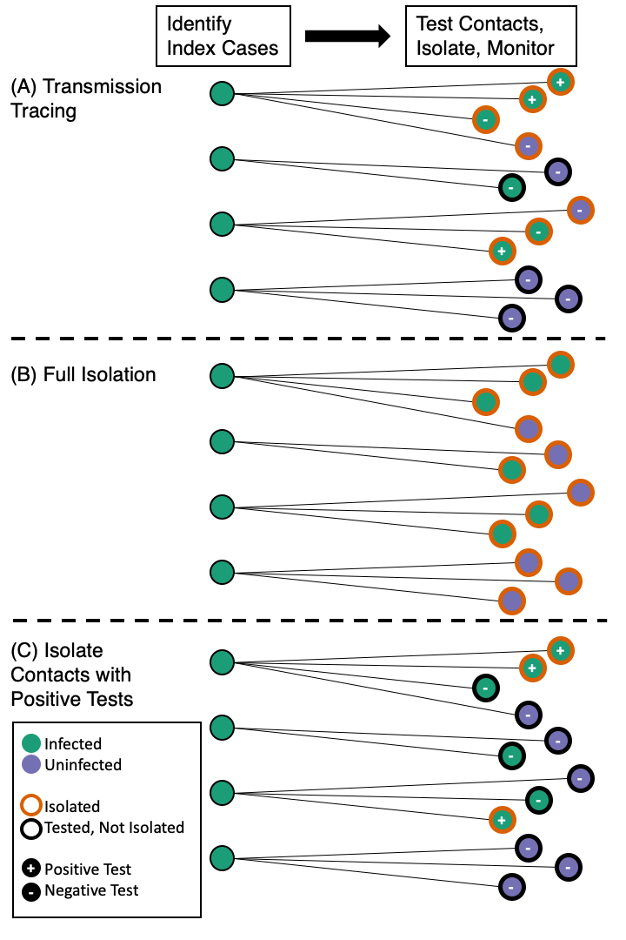

**Fig. 1.**  Schematic of three approaches to test and trace contacts of infected individuals: (A) transmission tracing; (B) full isolation of identified contacts; and (C) isolation of contacts who test positive. Infected individuals are green; uninfected individuals are purple. Individuals who test positive are denoted “+” and those who test negative are denoted “-”. Isolated contacts have an orange border while contacts who are not isolated have a black border.

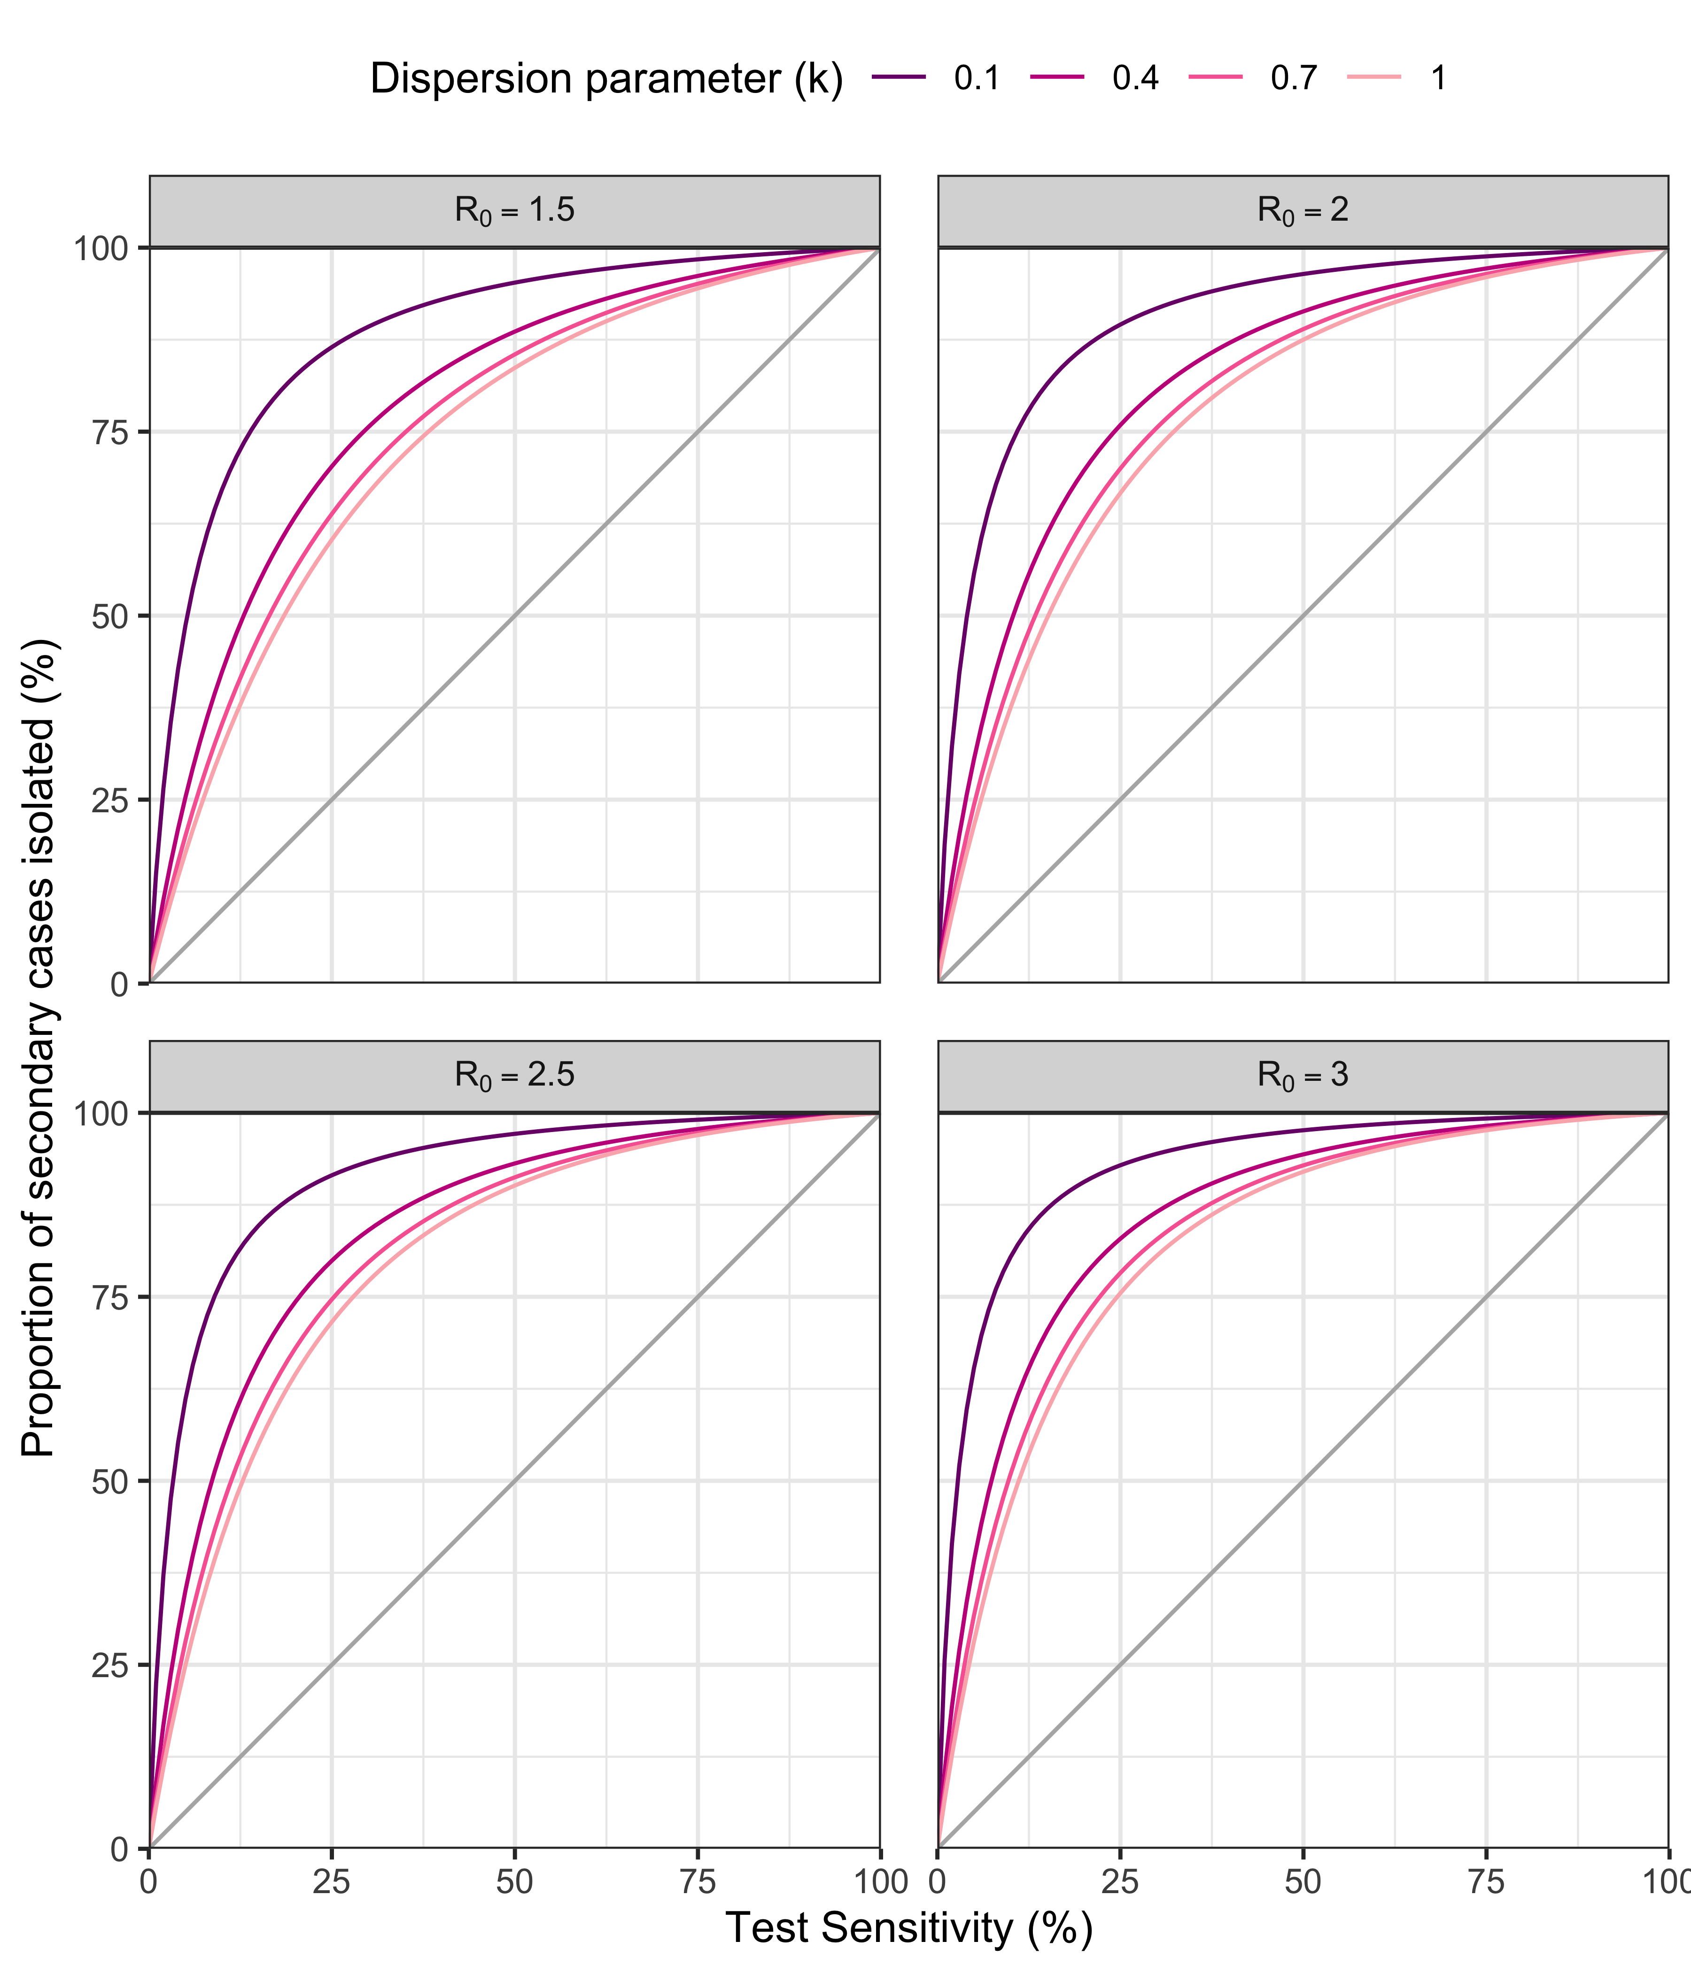**Fig. 2.** Proportion of secondary cases isolated under the transmission tracing strategy vs. test sensitivity by R0and *k*. The diagonal line indicates the proportion of secondary cases who test positive and are isolated under strategy C.

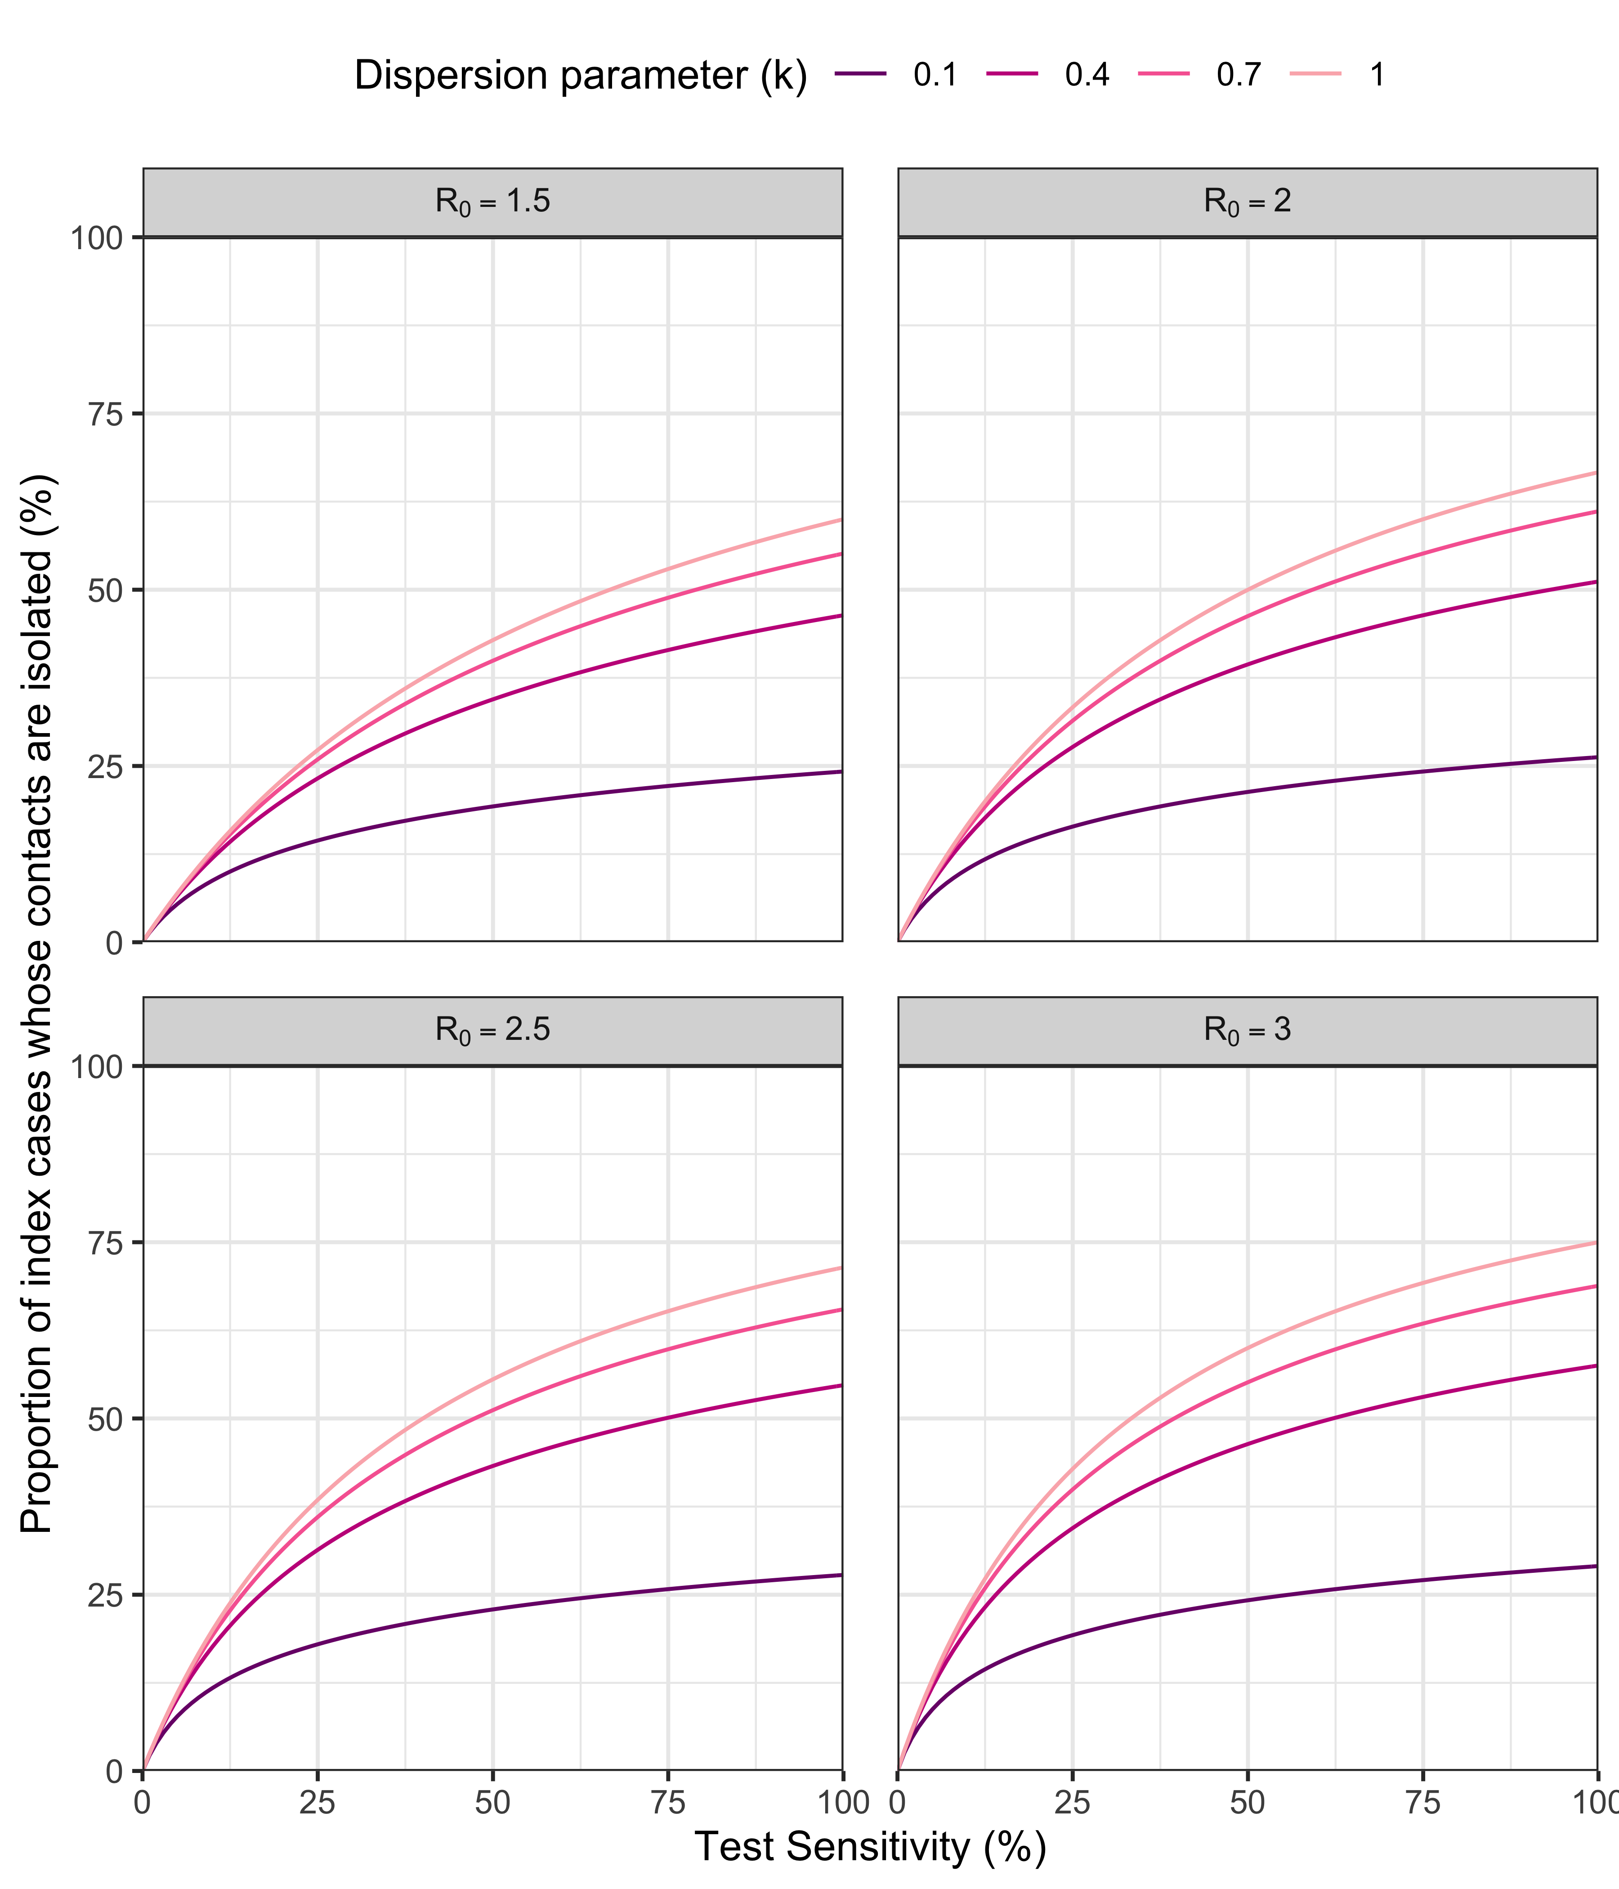**Fig. 3.** Proportion of index cases whose contacts are isolated under the transmission tracing strategy vs. test sensitivity by R0and *k*.

(Please delete before submission) Supplementary materials should be included in a separate supplementary materials file. A template for this file can be found at: <http://www.sciencemag.org/sites/default/files/Science_Supplementary_Materials_Word_template.docx>.